- Fleet Admin Dashboard:
- Screen Sections: The very top header with the application logo and main module links (Technical, Dashboard, Cert & Surveys, Defects, PMS, Admin).
- Left Sidebar (Main Menu): The vertical navigation bar on the left with links to the main application areas (Dashboard, Components, Work Orders, Running Hrs, Spares, Stores, Reports, Modify PMS, Admin).
- Screen Title Area: The section with the primary title "Fleet Admin Data" and the secondary navigation tabs (Bulk Data Imp, Alerts, Forms, Admin4).
- Dashboard Header: The main title and description for the dashboard (Fleet Admin Dashboard).
- Metrics Cards (Key Data): The four summary cards showing key master data figures.
- Total Makers Card (Maker List)
- Total Model Card (Master Data)
- Total Fleet Components Card (Fleet Equipment Data)
- Total Master Card (Master List)
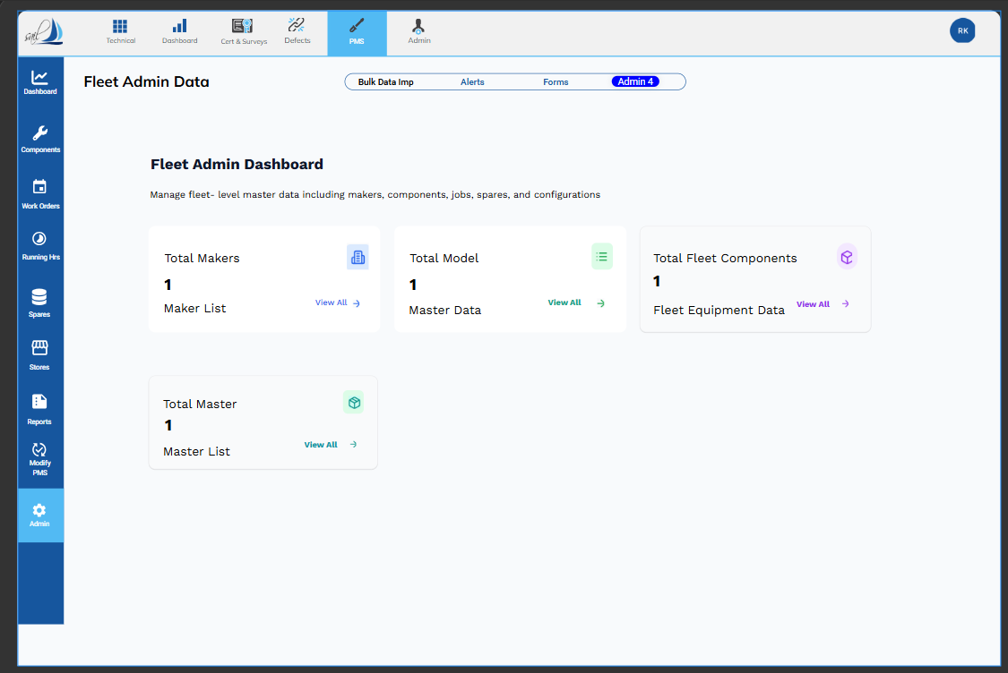

- Function Explanations of Screen Sections:
- Top Navigation Bar (Modules):
Section | Function
Top Navigation Bar | This acts as the primary navigation for the entire application. It allows the user to switch between the main functional areas (or Modules) of the system, such as Technical, Dashboard, Defects, and PMS. The currently selected module, PMS, dictates the context for all subsequent navigation and data displayed.

- Left Sidebar (Main Menu):
Section | Function
Left Sidebar (Main Menu) | This provides secondary navigation within the currently selected module (PMS). It links to the high-level screens or features (e.g., Components, Work Orders, Reports). The currently selected item, Admin, directs the main content area to display administrative controls related to the PMS or overall Fleet data.

- Screen Title Area (Sub-Navigation)
Section | Function
Screen Title Area | This section provides tertiary navigation within the "Admin" context. The tabs (Bulk Data Imp, Alerts, Forms, Admin 4) allow users to navigate between specific administrative tools. "Admin 4" is currently selected, indicating this screen focuses on a specific set of administrative tasks or master data setup.

- Dashboard Header:
Section | Function
Dashboard Header | This provides context for the screen. "Fleet Admin Dashboard" and its description clarifies that the purpose of this screen is to Manage fleet-level master data (makers, components, jobs, etc.) and serves as the landing page for all administration activities.

- Metrics Cards (Key Data):
Section | Function
Metrics Cards | These cards provide a summary overview of the core master data entities managed by the Fleet Admin. They serve as quick indicators of volume and status for key setup data. They are typically actionable, providing a count (e.g., 1 Total Makers) and a link (View All) to navigate directly to the detailed list or management screen for that specific data type.

- Functions of the Metric Cards (Key Data):
  - Maker List
Card Name (Destination Link) | Metric Displayed | Function
Total Makers Card (Maker List) | Number of Makers (Manufacturers) currently defined in the system (1) | Shows the total count of equipment manufacturers (Makers). Clicking on View All navigates to the Maker List screen, where a user can view, add, edit, or delete the list of Makers.

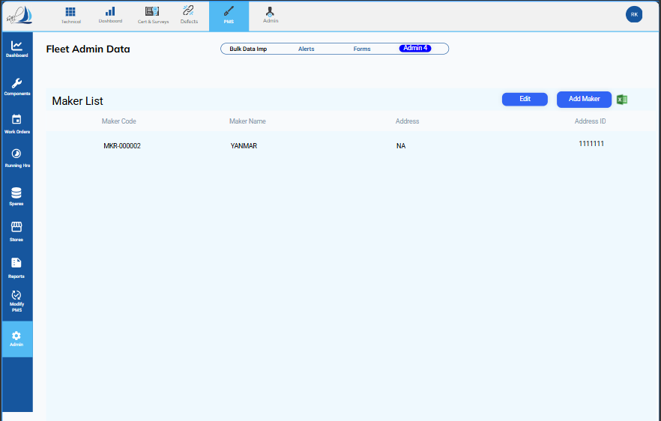

    - Screen Sections:
- Screen Title Area: The section with the primary title "Fleet Admin Data" and the secondary navigation tabs (Bulk Data Imp, Alerts, Forms, Admin 4).
- Section Header: The specific title for the current view (Maker List).
- Action Buttons: The area containing primary action buttons for the list (e.g., Edit, Add Maker and Export to Excel).
- Maker List Table: The main content area displaying the list of Makers with columns for key data.

      - Action Buttons.
- Edit: Select the line, click the "Edit" button to open the modification screen, update the required field(s), and click "Save."
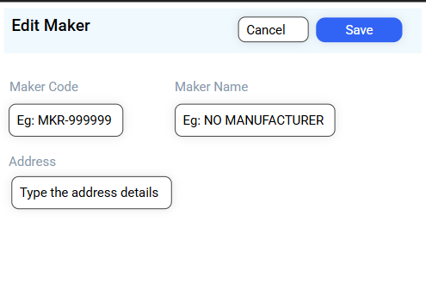

- Add Maker: To add new maker details to the maker list: Click the "Add New" button. The screen mentioned below will pop up. Enter all the required details (Maker Name and Maker Code are mandatory fields) and click "Save."
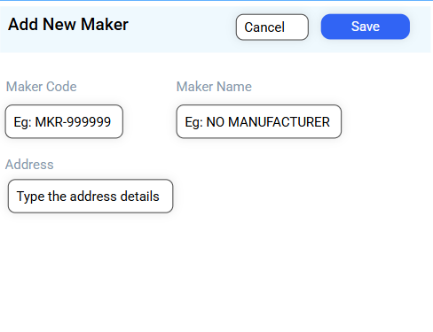

- Export to excel: To export the Maker list in the same format to an Excel sheet, click "Export to Excel." The file will be downloaded in Excel format.

      - Maker List Linkages.

- Admin Module
- Admin 4 Sub-Section
  - Master Data
    - -> Linked Fields: Maker Name, Maker Code
  - Fleet Equipment Data
    - -> Linked Fields: Maker Name, Maker Code
  - Fleet Data – Fleet Spares Information
    - -> Linked Fields: Maker Name, Maker Code
- Spares Module
  - Spares Inventory
    - -> Linked Fields: Maker Name, Maker Code
- Component Module
- A. Component Information
    - -> Linked Fields: Maker Name, Maker Code

  - Master Data
Card Name / Destination Link | Metric Displayed | Function
Total Model Card (Master Data) | Number of Models associated with the Master Data. | Shows the total count of specific equipment models defined. Clicking View All navigates to a comprehensive Master Data screen, which likely covers the details of all Fleet Equipment Codes.

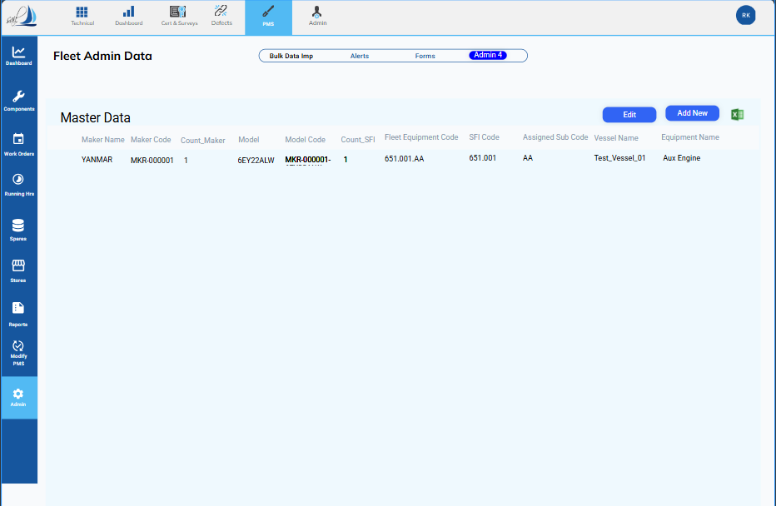

    - Screen Sections:
- Screen Title Area: The persistent section with the primary title "Fleet Admin Data" and the secondary navigation tabs (Bulk Data Imp, Alerts, Forms, Admin 4).
- Section Header: The specific title for the current view (Master Data).
- Action Buttons: The area containing primary action buttons for managing the list (e.g., Edit, Add New, and the Export/Excel icon).
- Master Data Table: The main content area displaying the list of fleet models/equipment, along with associated codes and names.

      - Action Buttons.
- Edit: Select the line, click the "Edit" button to open the modification screen, update the required field(s), and click "Save."

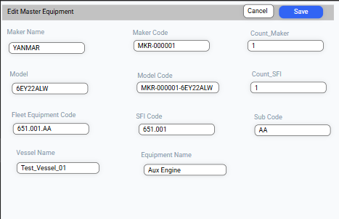

- Add New: To add new Master Equipment details to the Master Data, click the "Add New" button. The dedicated creation screen will pop up. Enter all the required details (all fields are mandatory) and click "Save."
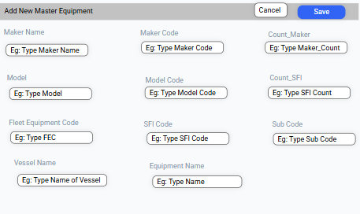

- Export to excel: To export the Master Data in the same format to an Excel sheet, click "Export to Excel." The file will be downloaded in Excel format.

      - Master Data Linkages.

- Admin Module
- Admin 4 Sub-Section
  - Fleet Equipment Data
- > Fleet Component Information:
    - -> Linked Fields: Fleet Equipment Code, Fleet Equipment Name, Model, Model Code

- Component Module
- A. Component Information
    - -> Linked Fields: Fleet Equipment Code, Fleet Equipment Name, Model, Model Code

  - Fleet Equipment Data
Card Name / Destination Link | Metric Displayed | Function
Total Fleet Components Card (Fleet Equipment Data) | Number of Fleet Components defined in the system. | Shows all the Fleet Equipment, along with the Jobs and Spares linked to each. Clicking View All navigates to a comprehensive Fleet Equipment Data Screen, which likely covers the details of Fleet Equipment, Jobs, and its Spares.

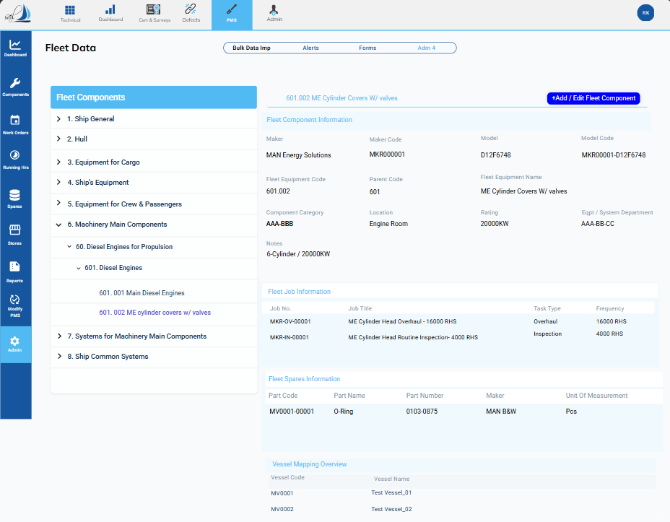

    - Screen Sections:
The screenshot confirms the following navigation context:
- Top Navigation (Module): PMS is selected.
- Left Sidebar (Area): Admin is selected.
- Sub-Navigation Tab: Admin 4 is selected.
- Action: The user clicked "View All" from the Fleet Equipment Data metric card.
Section | Role / Function | Key Content
Fleet Components Tree | Hierarchical navigation for equipment setup. | Structured list categories (e.g., Ship General, Hull, Machinery Main Components) leading down to individual components (e.g., 601.002 ME Cylinder Covers w/ valves).
Action Buttons | Top-right area for list management. | +Add / Edit Fleet Component button.
Fleet Component Information | Detailed static data for the selected component. | Maker, Model, Model Code, Equipment Code, Parent Code, Rating, Location, etc.
Fleet Job Information | List of maintenance jobs or tasks associated with this component. | Job No., Job Title, Task Type, Frequency.
Fleet Spares Information | List of specific spare parts required for this component/job. | Part Code, Part Name, Part Number, Maker, Unit of Measurement.
Vessel Mapping Overview | Shows which vessels this generic component is installed on. | Vessel Code, Vessel Name.

      - Action Buttons.
- +Add / Edit Fleet Component : .
1. Select the specific component you wish to modify from the Component Tree View (left pane).
2. Click the +Add / Edit Fleet Component button.
3. The modification screen will open, pre-populated with existing data.
4. Make the necessary changes.
5. Click "Save.
- 1. Select the desired Parent Component from the Component Tree View.
2. Click the + Add Sub Equipment button.
3. Enter the required details for the new component.
4. Click "Save."

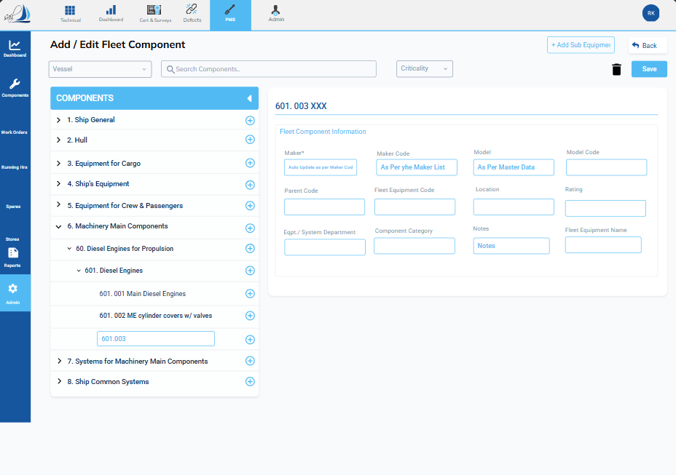

      - Fleet Job Information:
- When you click on ‘Fleet Job Information’, the screen shown below will open. It will contain the complete details of all jobs linked to the fleet equipment code.
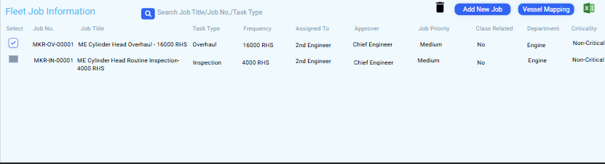

Fleet Job Information Management Screen
1. Screen Context & Purpose
- Title: Fleet Job Information
- Purpose: To define, view, and manage all scheduled and routine maintenance jobs associated with a selected Fleet Equipment Code. This screen is the link between the equipment master data and the Planned Maintenance System (PMS).
2. Action Buttons
The screen includes several primary action buttons for job management:
Button Icon / Name | Standard Function | Note
Search | Allows users to quickly locate jobs using filters like Job Title, Job No., or Task Type. | Improves list usability.
Trash/Delete | Used to delete selected jobs from the list. | Requires user to select jobs using the "Select" checkbox first.
Add New Job | Used to create and link a new maintenance job to the current Fleet Equipment Code. | This will likely open a job creation form.
Vessel Mapping | Used to manage the assignment or applicability of these jobs across different vessels in the fleet. | Links job definitions to specific deployed assets.
Export/Excel Icon | Exports the current list of job information to an Excel file. | Standard list export functionality.

3. Job Details Displayed
The table provides a comprehensive overview of each linked job with the following columns:
Column Header | Data Type / Significance
Job No. | Unique identifier for the job (e.g., MKR-OV-00001).
Job Title | Descriptive title of the task, including frequency reference (e.g., ME Cylinder Head Overhaul - 16000 RHS).
Task Type | Categorization of the job (e.g., Overhaul, Inspection).
Frequency | The interval at which the job should occur (e.g., 16000 RHS, 4000 RHS).
Assigned To | The role or personnel primarily responsible for execution (e.g., 2nd Engineer).
Approver | The role or personnel required to authorize the job (e.g., Chief Engineer).
Job Priority | The relative importance or urgency of the job (e.g., Medium).
Class Related | Indicates if the job is relevant to Classification Society requirements (Yes/No).
Department | The technical department responsible for the job (e.g., Engine).
Criticality | The impact level if the job is delayed or missed (e.g., non-critical).

Vessel Mapping Screen
This screen allows the user to link or unlink the currently managed job definition to specific physical vessels within the fleet.
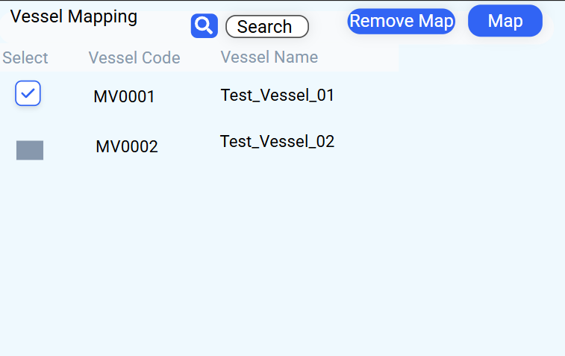

1. Screen Sections
Section | Role / Content
Title | Vessel Mapping
Data Table | Display the list of vessels in the fleet that are linked to this Fleet Equipment code.
Columns | Select, Vessel Code (e.g., MV0001), Vessel Name (e.g., Test_Vessel_01).
2. Action Button Functionality
The primary actions involve searching, linking (mapping), and unlinking (removing) vessels.
Button Name | Functionality | Process Flow
Search | Allows the user to find vessels quickly by Code or Name. | User enters criteria Clicks Search.
Map | Links the current job definition to the selected vessel(s). | 1. Select one or more vessels using the Select checkbox.  2. Click Map.
Remove Map | Unlinks the current job definition from the selected vessel(s). | 1. Select one or more vessels using the Select checkbox.  2. Click Remove Map.

Add New Job Information Screen
This form is used to define all parameters for a new maintenance job within the Planned Maintenance System (PMS) and associate it with a Fleet Equipment type.

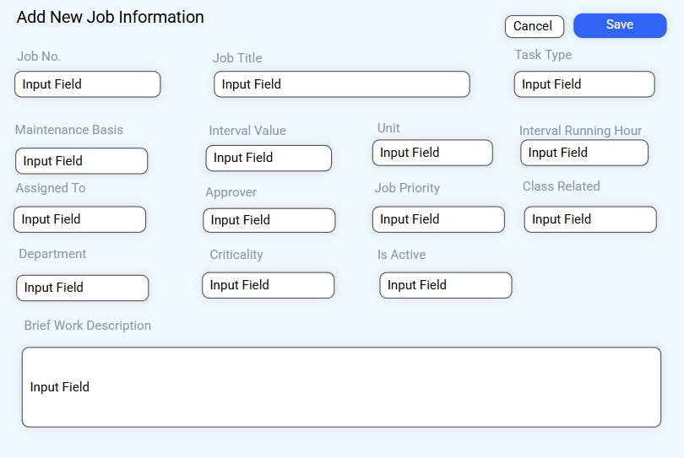

1. Field Details and Definition
Field Name | Expected Input / Type | Notes
Job No. | Unique alphanumeric code | Mandatory identifier for the job.
Job Title | Text | Descriptive name of the maintenance task.
Task Type | Select/Input | Categorizes the job (e.g., Overhaul, Inspection, Service).
Maintenance Basis | Select/Input | Defines the type of scheduling (e.g., Calendar, Running Hours, Cycle Count).
Interval Value | Numeric | The duration (e.g., '6' for months) based on the Unit.
Unit | Select/Input | The time unit for the interval (e.g., 'Months', 'Weeks').
Interval Running Hour | Numeric | The hour-based frequency (e.g., '4000' hours). This is used if the Maintenance Basis is 'Running Hours'.
Assigned To | Select/Input (Role/Personnel) | Who is responsible for performing the job (e.g., 2nd Engineer).
Approver | Select/Input (Role/Personnel) | Who authorizes the job's completion (e.g., Chief Engineer).
Job Priority | Select/Input | Relative urgency (e.g., High, Medium, Low).
Class Related | Select/Input (Yes/No) | Indicates if the job is required for Classification Society compliance.
Department | Select/Input | The department owning the job (e.g., Engine, Deck).
Criticality | Select/Input | The impact level if the job is missed (e.g., Critical, Non-Critical).
Is Active | Select (Yes/No) | Status toggle for the job definition.
Brief Work Description | Large Text Area | Detailed instructions or scope of work.
3. Action Buttons
Button | Functionality
Save | Commits all entered job information and links the new job to the selected Fleet Equipment Code.
Cancel | Discards all entered data and closes the form.

Job Details Screen
This screen provides a read-only, comprehensive summary of a single selected maintenance job. It is accessed by double-clicking a job entry on the Fleet Job Information list.
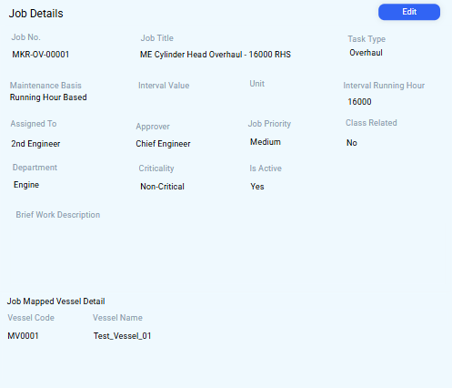

1. Screen Sections
The screen is logically divided into three main sections:
Section | Content | Purpose
Job Core Data | Job No., Job Title, Task Type, Maintenance Basis, Interval Running Hour, Unit. | Displays the unique identifiers and scheduling parameters of the job.
Workflow & Admin | Assigned To, Approver, Job Priority, Class Related, Department, Criticality, Is Active. | Shows who is responsible and the administrative status of the job.
Job Mapped Vessel Detail | Vessel Code, Vessel Name. | Confirms which specific vessels this job definition is currently applied to.
Brief Work Description | Large text area (currently empty). | Where the actual instructions or scope of work for the job are stored.

2. Action Button
Button | Functionality
Edit | Allows the user to switch this read-only view into the modification mode (similar to the Add New Job screen) to make changes to the job parameters.

Edit Job Details Screen
This screen is the primary interface for modifying the parameters of a previously defined maintenance job.
1. Access and Purpose
- Access: Typically accessed via the "Edit" button on the read-only Job Details screen.
- Purpose: Allows authorized users to edit the job details.
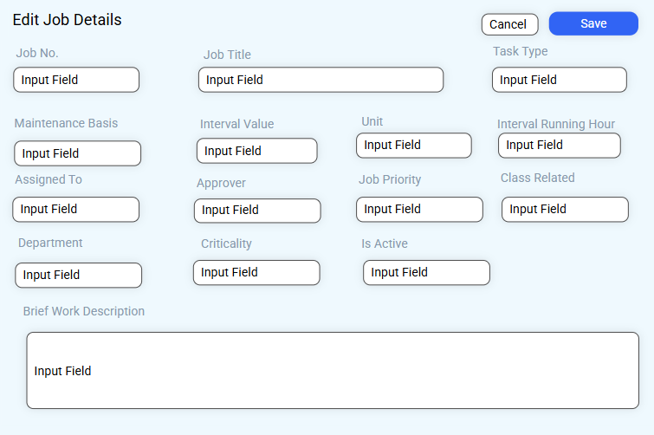

2. Action Buttons
Button | Functionality
Save | Commits all modifications to the existing job record, ensuring the PMS (Planned Maintenance System) uses the updated parameters for future scheduling.
Cancel | Discards any changes made during the editing session and returns to the previous screen (likely the read-only Job Details).

Fleet Spares Information Management Screen
- When you click on ‘Fleet Spares Information’, the screen shown below will open. It will contain the complete details of all Spares linked to the fleet equipment code.
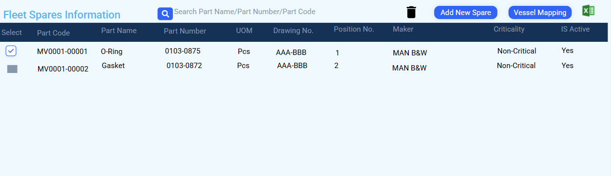

1. Screen Context & Purpose
- Title: Fleet Spares Information
- Purpose: To define, view, and manage the list of necessary spare parts associated with the current Fleet Equipment Code. This information links the equipment and its jobs to the Spares and Stores inventory modules.
2. Action Buttons
The screen includes several primary action buttons for spare part management:
Button Icon / Name | Standard Function | Note
Search | Allows users to quickly locate spare parts using filters like Part Name, Part Number, or Part Code. | Improves list usability.
Trash/Delete | Used to delete selected spares from the component's linked list. | Requires the user to select spares using the "Select" checkbox first.
Add New Spare | Used to create and link a new spare part to the current Fleet Equipment Code. | This will open a spare part creation/selection form.
Vessel Mapping | Used to manage the assignment or applicability of these spares across different vessels in the fleet. | Ensures the right parts are available for the right vessels.
Export/Excel Icon | Exports the current list of spare information to an Excel file. | Standard list export functionality.

3. Spares Details Displayed
The table provides a comprehensive overview of each spare part linked to the component:
Column Header | Data Type / Significance | Example Data
Part Code | Unique identifier for the spare part. | MV0001-00001
Part Name | Descriptive name of the part. | O-Ring, Gasket
Part Number | Manufacturer's reference number. | 0103-0875
UOM | Unit of Measurement (e.g., how the part is counted/ordered). | Pcs (Pieces)
Drawing No. | Reference to the technical drawing where the part is located. | AAA-BBB
Position No. | Specific location or sequence number of the part within the component assembly. | 1, 2
Maker | Manufacturer of the spare part. | MAN B&W
Criticality | The importance/impact of the spare part (e.g., safety, operational). | Non-Critical
Is Active | Status toggle for the spare definition (Yes/No). | Yes

Vessel Mapping Screen
This screen allows the user to link or unlink the currently managed Spare details to specific physical vessels within the fleet.


1. Screen Sections
Section | Role / Content
Title | Vessel Mapping
Data Table | Display the list of vessels in the fleet that are linked to this Fleet Equipment code.
Columns | Select, Vessel Code (e.g., MV0001), Vessel Name (e.g., Test_Vessel_01).
2. Action Button Functionality
The primary actions involve searching, linking (mapping), and unlinking (removing) vessels.
Button Name | Functionality | Process Flow
Search | Allows the user to find vessels quickly by Code or Name. | User enters criteria Clicks Search.
Map | Links the current Spare definition to the selected vessel(s). | 1. Select one or more vessels using the Select checkbox.  2. Click Map.
Remove Map | Unlinks the current Spare definition from the selected vessel(s). | 1. Select one or more vessels using the Select checkbox.  2. Click Remove Map.

Add New Spare Details Screen
This form is used to define all master data parameters for a new spare part and associate it with a specific Fleet Equipment type. This information is critical for inventory management and maintenance planning.

1. Field Details and Definition
Field Name | Expected Input / Type | Notes
Part Code | Unique alphanumeric code | Mandatory identifier for the spare part master record.
Part Name | Text | Descriptive name of the spare part (e.g., O-Ring, Gasket).
Part Number | Alphanumeric | Manufacturer's official reference number.
Drawing Number | Alphanumeric | Reference to the technical drawing where the part is located.
Maker | Select/Input | Name of the spare part manufacturer (linked to the Maker List).
Maker Code | Alphanumeric | Code of the spare part manufacturer (linked to the Maker List).
Is Active | Select (Yes/No) | Status toggle for the spare definition.
Position Number | Numeric | Specific location or sequence number of the part within the assembly.
Criticality | Select/Input | The impact level if the spare part is unavailable (e.g., Critical, Non-Critical).
Unit of Measurement | Select/Input | The unit used for ordering and stocking the part (e.g., Pcs, Mtr, Kgs).
Specification | Large Text Area | Detailed technical requirements or standards for the part.
Note | Large Text Area | General administrative notes or context.
3. Action Buttons
Button | Functionality
Save | Commits all entered spare part information and links the new spare to the selected Fleet Equipment Code.
Cancel | Discards all entered data and closes the form without saving.

Spare Details Screen
This screen provides a comprehensive, read-only summary of a single selected spare part record.
1. Screen Sections
The screen is logically divided into three primary sections:
Section | Content Displayed | Purpose
Identification & Technical Data | Part Code, Part Name, Part Number, Drawing Number, Maker, Maker Code, Specification, Unit of Measurement (UOM), Position Number, Criticality. | Displays the unique identifiers, manufacturing source, and technical characteristics of the spare part.
Administrative Data | Is Active, Note. | Shows the current status and any general administrative notes.
Spare Mapped Vessel Details | Vessel Code, Vessel Name. | Confirms which specific vessels this spare part definition is currently required on, linking the spare to the physical assets.

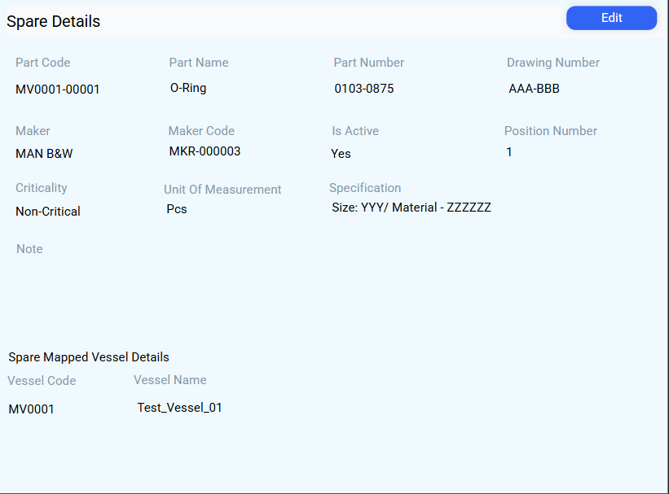

2. Key Data Points Illustrated
The example spare part, O-Ring., illustrates several linked data points:
- Manufacturer Linkage: Maker is MAN B&W, linked by Maker Code.
- Technical Detail: Specification includes Size (YYY) and Material (ZZZZZ).
- Vessel Mapping: Currently mapped to MV0001 (Test_Vessel_01).
3. Action Button
Button | Functionality
Edit | Allows the user to switch this read-only view into the modification mode to make changes to the spare part's master data (similar to the Add New Spare Details screen).

Edit Spare Details Screen
This screen is the primary interface for modifying the master data parameters of a previously defined spare part.
1. Access and Purpose
- Access: Typically accessed via the "Edit" button on the read-only Spare Details screen.
- Purpose: Allows authorized users to update the spare part's identifiers, technical specifications, manufacturer details, and administrative status.
2. Form Sections and Editable Fields
All fields on this form are editable and pre-filled with the current spare part data, ensuring users can adjust any parameter necessary for inventory and maintenance planning.
Section | Fields Included | Key Functionality
Identification & Inventory | Part Code, Part Name, Part Number, Unit of Measurement (UOM), Drawing Number, Position Number | Modification of the core identifiers and inventory tracking data.
Manufacturer Details | Maker, Maker Code | Adjustment of the associated manufacturer information.
Technical & Administrative | Criticality, Specification, Is Active, Note | Modification of the part's importance, technical requirements, and status.
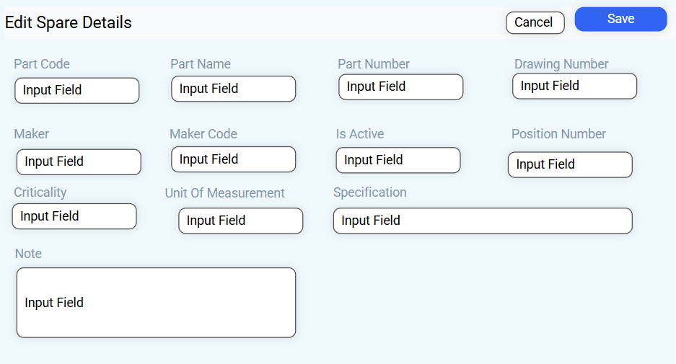

3. Action Buttons
Button | Functionality
Save | Commits all modifications to the existing spare part record, updating the master inventory data used by the system.
Cancel | Discards any changes made during the editing session and returns to the previous screen (likely the read-only Spare Details).
Vessel Mapping Overview Screen
This screen allows the user to link or unlink the Fleet Equipment Code to specific physical vessels within the fleet.
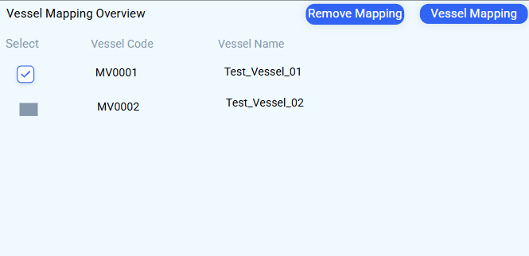

1. Screen Sections
Section | Role / Content
Title | Vessel Mapping Overview
Data Table | Displays a list of all available vessels in the fleet.
Columns | Select (checkbox), Vessel Code, Vessel Name.

2. Action Button Functionality
The primary actions involve linking (mapping) and unlinking (removing) vessels.
Button Name | Functionality | Process Flow
Vessel Mapping | Links the current entity (Fleet Equipment Code) to the selected vessel(s). | 1. Select one or more vessels using the Select checkbox.  2. Click Vessel Mapping.
Remove Mapping | Unlinks the current entity from the selected vessel(s). | 1. Select one or more vessels using the Select checkbox.  2. Click Remove Mapping.

Vessel Mapping Search & Selection
This screen is used to find and select specific vessels from the entire fleet to link Fleet Equipment Code to them.

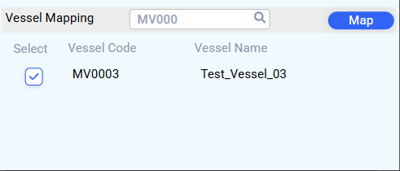

1. Screen Sections & Purpose
Section | Role / Content
Title | Vessel Mapping
Search Bar | An input field where the user can enter a Vessel Code (e.g., MV0000) or Vessel Name to filter the list. The magnifying glass icon executes the search.
Data Table | Displays the vessels found, allowing selection.
2. Action Button Functionality
The primary action here is linking the selected vessel(s) to the Fleet Equipment Code.
Button Name | Functionality | Process Flow
Map | Links the current Fleet Equipment Code to the selected vessel(s). | 1. Select the desired vessel(s) (e.g., MV0003). 2. Click the Map button.

Vessel Component Mapping Overview
This screen is accessed by double-clicking on a Vessel Name or Vessel Code within the primary Vessel Mapping Overview screen.
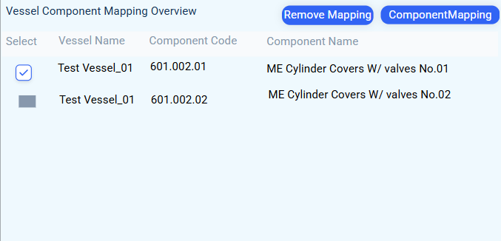

1. Screen Context & Purpose
- Purpose: To define, view, and manage the mapping between a single generic Master Fleet Equipment Code (like the 601.002 ME Cylinder Covers w/ valves type) and its individual, numbered instances installed on a specific vessel (e.g., Test_Vessel_01).
- Key Concept: This step is crucial for separating the Template (Fleet Equipment Code) from the Asset (the component on the vessel, often called a Tag or Asset Number).
2. Data Displayed
The table shows the list of components on the selected vessel that are linked to the master Fleet Equipment Code being managed.
Column Header | Data Type / Significance | Example Data
Select | Checkbox for mapping actions. | Indicates selection status.
Vessel Name | The name of the vessel being inspected. | Test_Vessel_01
Component Code | Vessel-Side Asset Code. The unique identifier for the physical component instance on the vessel. | 601.002.01, 601.002.02
Component Name | The descriptive name of the component instance, including its numbering/position on the vessel. | ME Cylinder Covers W/ valves No.01, No.02

3. Action Button Functionality
The primary actions manage the link between the Master (Fleet) component and the Vessel component instances.
Button Name | Functionality | Process Flow
Component Mapping | Links the generic Fleet Equipment Code to the selected Vessel Component Code(s). | 1. Select the desired Vessel Component Code(s).  2. Click Component Mapping.
Remove Mapping | Unlinks the generic Fleet Equipment Code from the selected Vessel Component Code(s). | 1. Select the mapped Vessel Component Code(s). 2. Click Remove Mapping.

Component Mapping Search & Selection
This screen is used to search for, select, and ultimately map individual physical component instances (on a specific vessel) to the generic Fleet Equipment Master Code currently being managed.
1. Screen Sections & Purpose
Section | Role / Content
Title | Component Mapping
Search Bar | An input field where the user enters a Component Code (e.g., 601.002.0) to filter the component instances available for mapping on the selected vessel. The magnifying glass icon executes the search.
Data Table | Displays the filtered component instances, allowing selection.

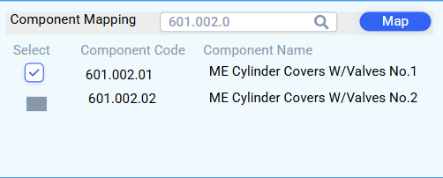

2. Action Button Functionality
The primary action here is establishing the final link between the template and the physical asset.
Button Name | Functionality | Process Flow
Map | Links the master Fleet Equipment Code to the selected component instance(s). | 1. Search for and select the desired Component Code(s) (e.g., 601.002.01). 2. Click the Map button.

Fleet Equipment Data Linkages.
- Admin Module
- Admin 4 Sub-Section
  - Master Data
    - -> Linked Fields: Fleet Equipment Code
- Components Module
- A. Component Information
    - -> Linked Fields: Fleet Equipment Code
- Component Module

Fleet Job Information Linkages.
- Components Module
- C Jobs
    - -> Linked Fields: Job No.
Fleet Spare Information Linkages.
- Components Module
- E Spares
    - -> Linked Fields: Part Code

d. Master List
Card Name / Destination Link | Metric Displayed | Function
Total Master Card (Master List) | A count of generic or other Master entities | Shows a summary count of a broader category of master data entities. Clicking View All navigates to the Master List screen, which may contain various lookups, common variables, or other foundational configuration items.

